SAUBANTIK DAS UG/02/BTCSECSF/2023/015
LAB 4
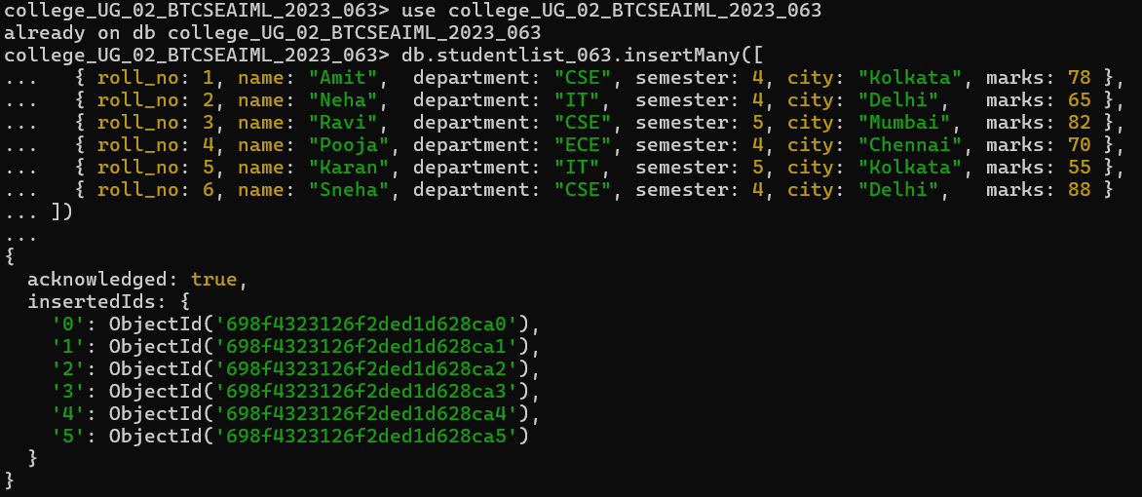
Q1. Display all student records using aggregation.
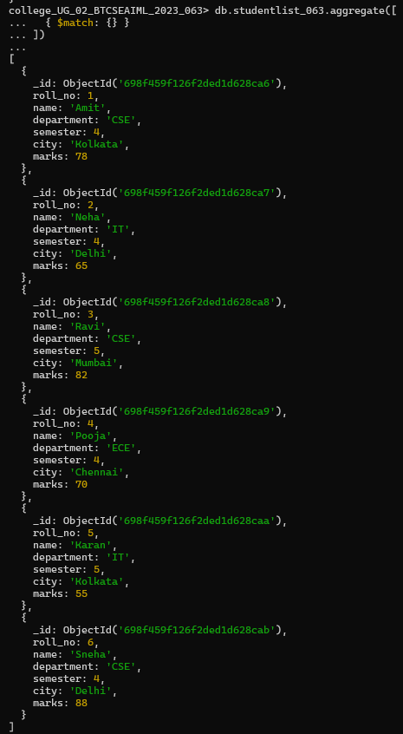

Q2. Display students belonging to CSE department.
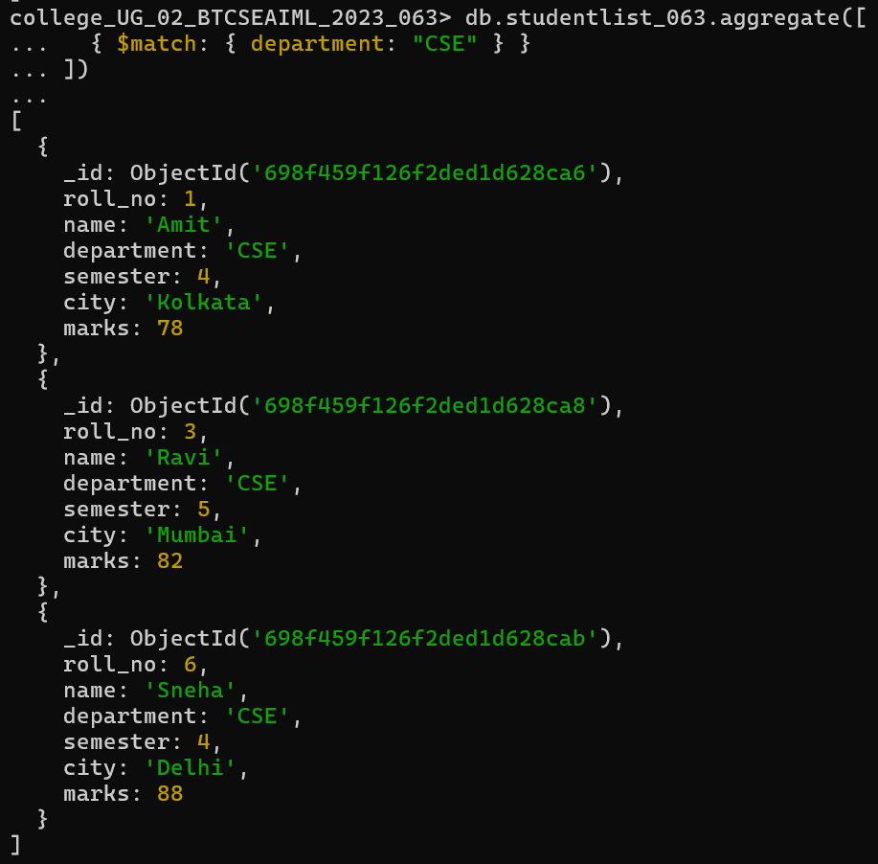

Q3. Display students of semester 4.
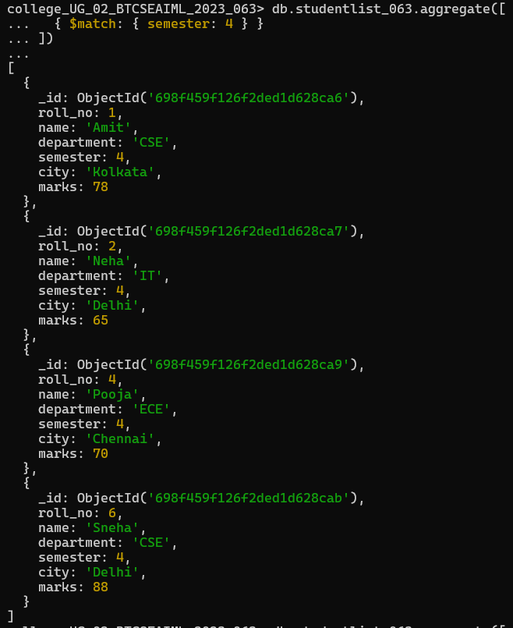
Q4. Display only name and marks of all students.
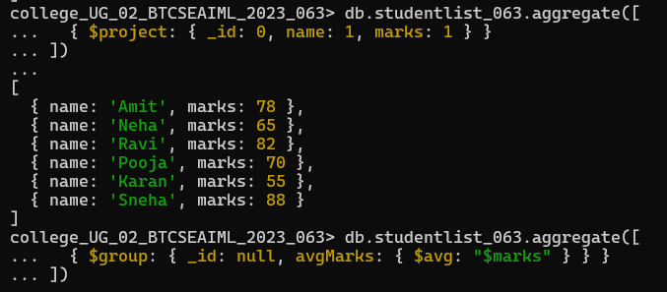

Q5. Find the average marks of all students.
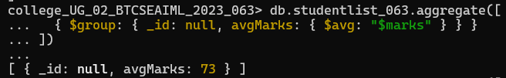
Q6. Find total marks scored department-wise.
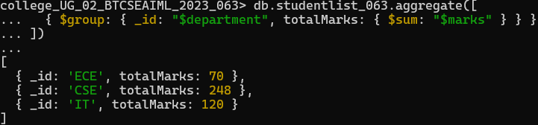
Q7. Find average marks department-wise.
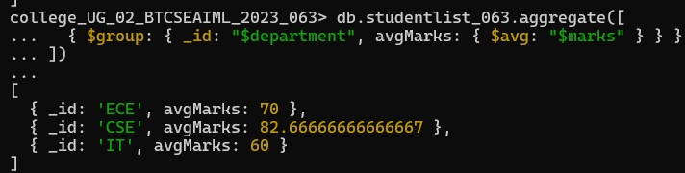
Q8. Find maximum marks scored in each department.
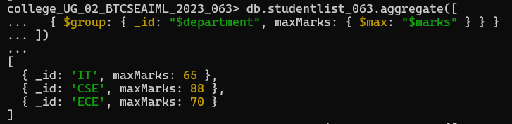
Q9. Count number of students in each department.
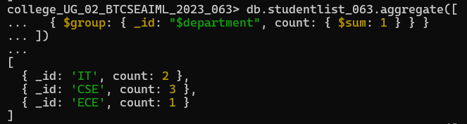
Q10. Display departments having average marks greater than 70.
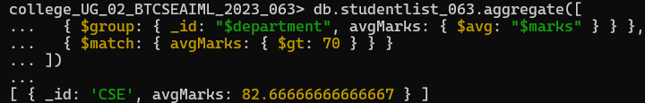
Q11. Sort students by marks in descending order.
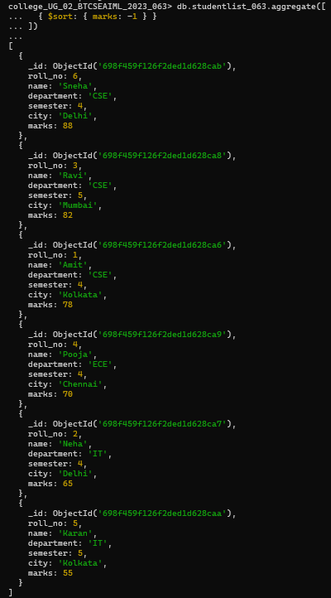

Q12. Display top 3 students based on marks.
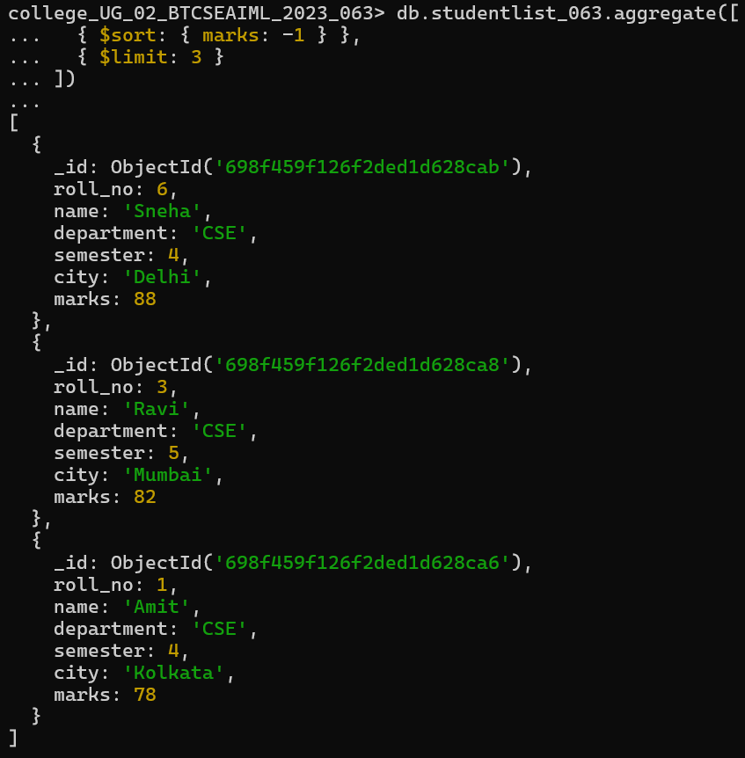
Q13. Display department-wise average marks sorted in descending order.
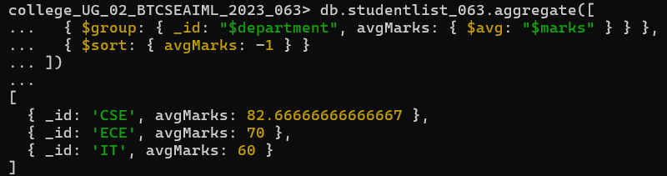

Q14. Display students belonging to Delhi or Kolkata
